Rider Destination selection Screen

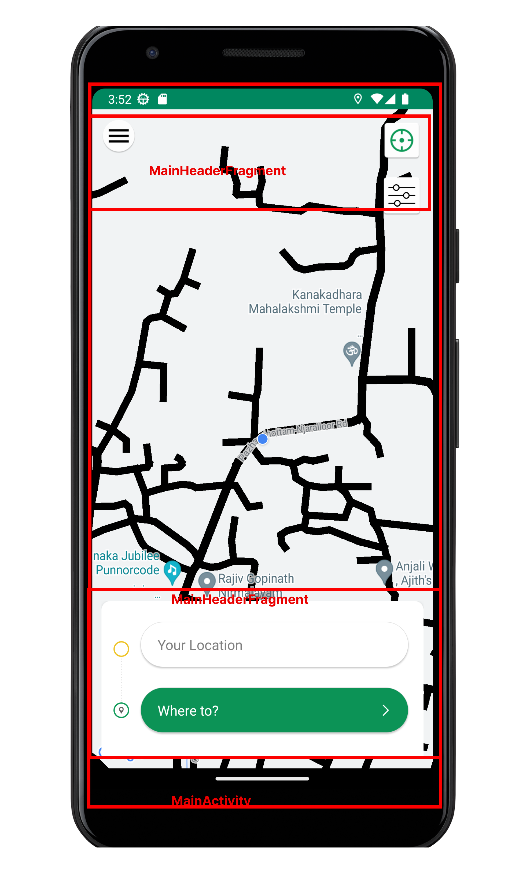

- MainActivity
- MainHeaderFragment

Send Request Screen

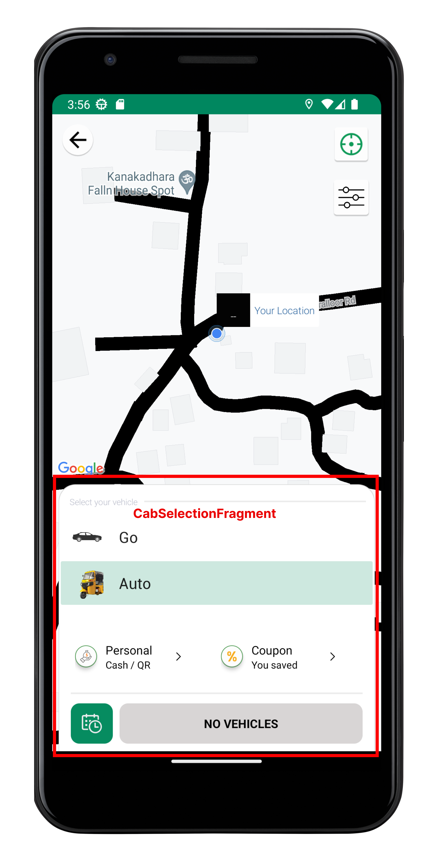

  - MainActivity
  - CabSelectionFragment

Ongoing Trip Screen

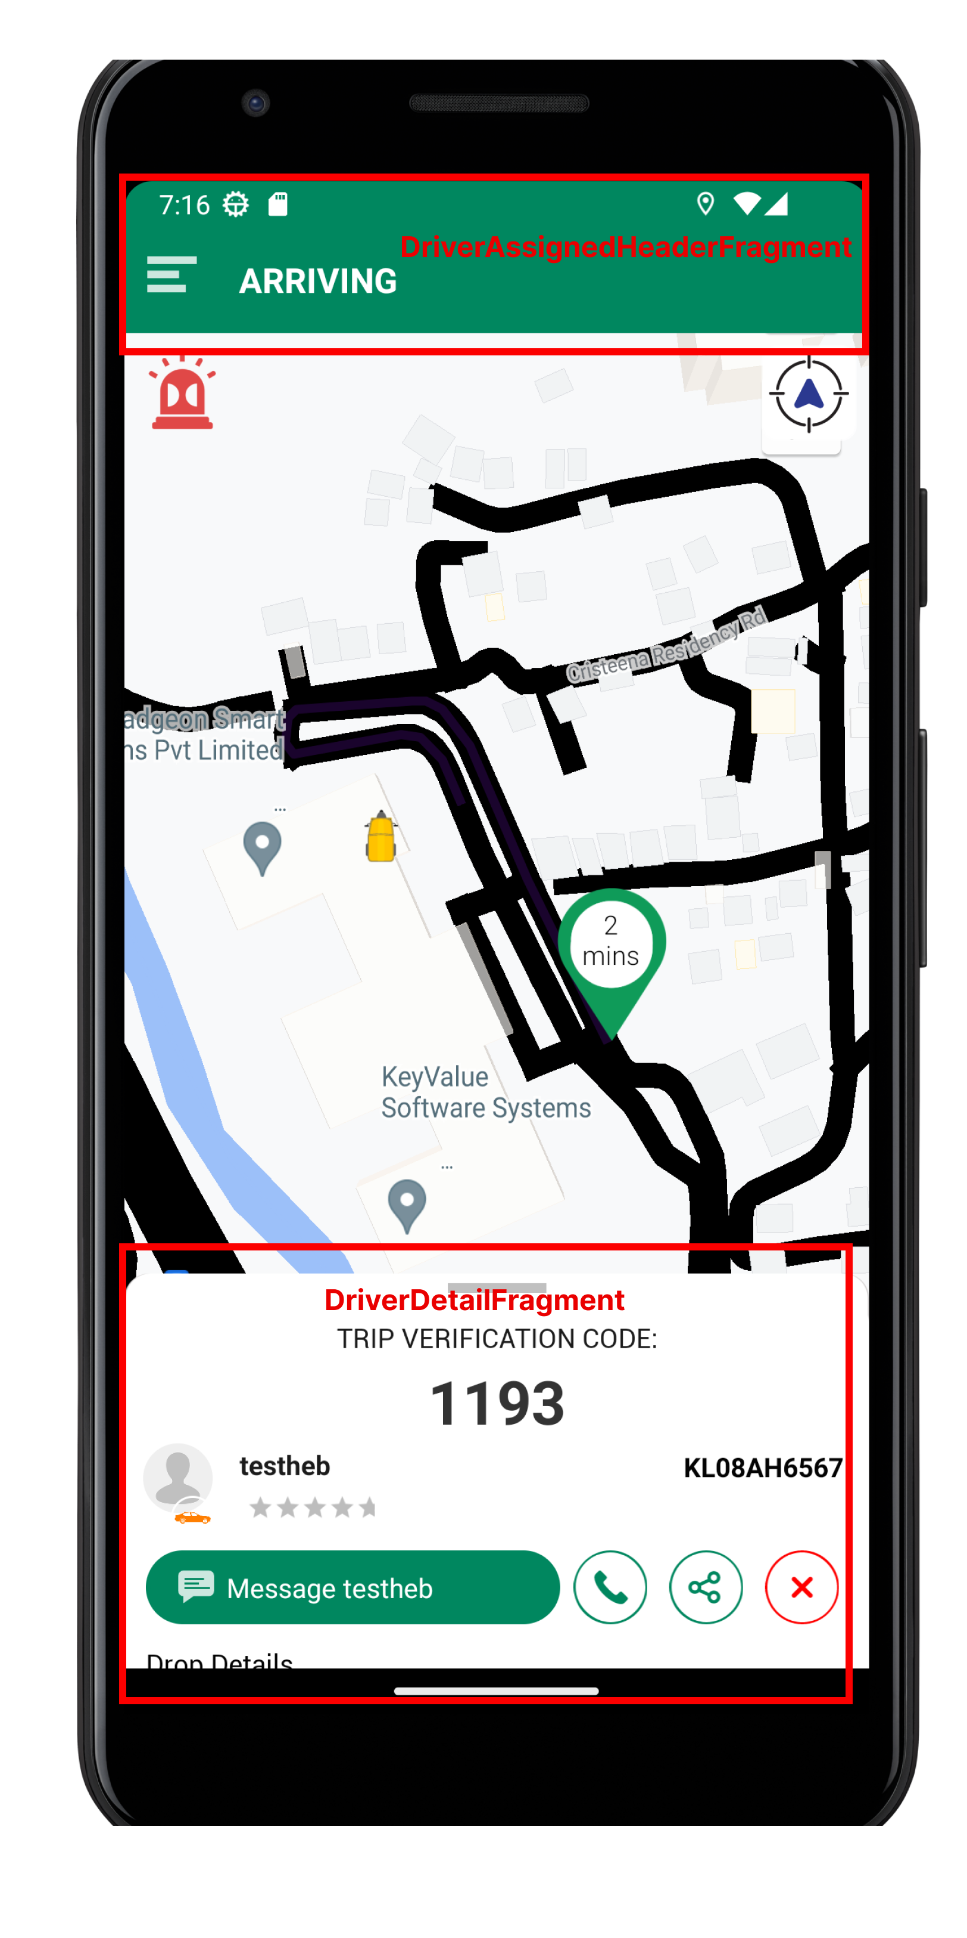

    - MainActivity
    - DriverAssignedHeaderFragment
    - DriverDetailFragment

